**Guide to Subtracting a Calculated Form Factor from Data**

AJJ 2019-04-02

1. Load the data you want to use. In this example we use the test dataset “ISIS_83404.TXT” that is included with SasView in the test/1d_data folder.

2. Send the data to fitting and you will see a set of windows something like this:

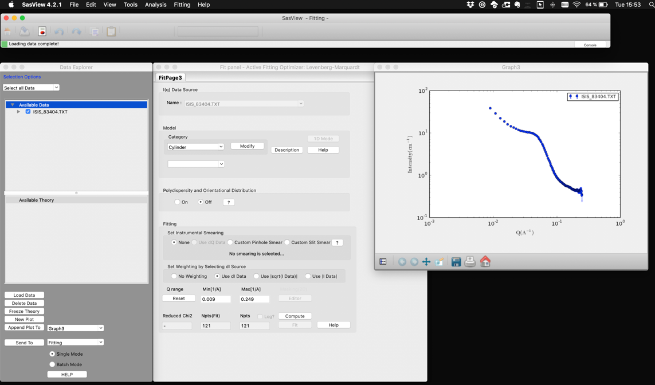

3. In the fit panel, choose the form factor you want to subtract and set/fit the values to get the curve you want. In our example, we will try to subtract a power law with background model from this data (NB, this may not be scientifically meaningful – it is used only as an example!). See the figure below. Once you are satisfied with the parameters of the model you can move to the next step.



4. From the “Tools” menu select “Data Operation” and the following panel will appear:

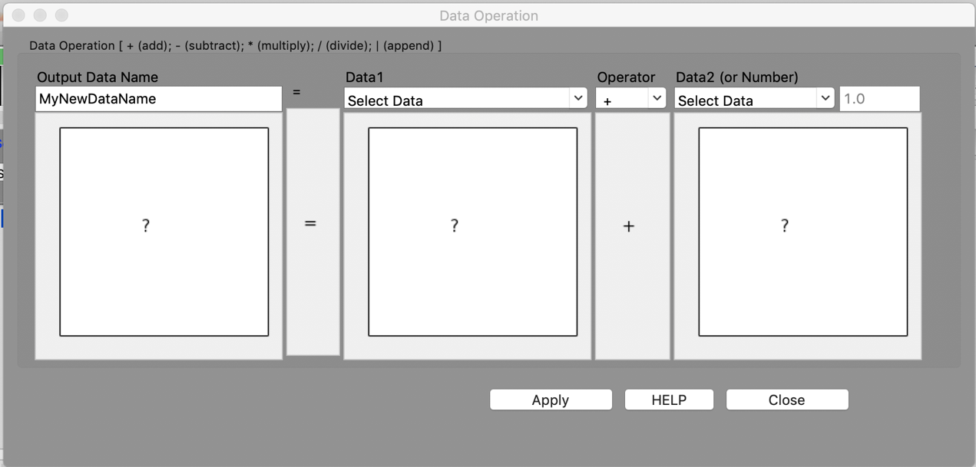

5. Set the “Output Data Name” however you want the subtracted dataset named. Here we have called it 83404_pl_sub. Then set Data1 to your dataset, set the operator to “-“ and Data2 to the model (called M<#> [dataset name] – here M3 [ISIS_83404.TXT]):



6. Click “Apply” and then “Close” and a new dataset with the name you chose will have appeared in the Data Explorer:



7. You can now plot that new dataset or send it to fitting or export it etc.

